

**ITMD-510 Object Oriented Programming (Phase 2)**

**Medical Student Study Application**



Minal Devanand Vaity – A20445368

Revision History

|  |  |  |  |
| --- | --- | --- | --- |
| Version No. | Date | Prepared by / Modified by | Significant Changes |
| 1.0 | 11/05/2019 | Minal Vaity | Initial project proposal. |
| 1.1 | 12/04/2019 | Minal Vaity | Application Knowledge and Known Error Database |

**Contents**

Introduction ........................................................................................................................................ 3

Main menu for Medical Student Study Application........................................................................... 3

User Credentials ................................................................................................................................. 4

Tools and Technologies Used………………………………………………...................................... 4

Installation Steps …............................................................................................................................. 5

Application Functionality..................................................................................................................... 5

Index Page ........................................................................................................................................... 6

Login Page ........................................................................................................................................... 6

Registration Page ................................................................................................................................. 7

Category Page ...................................................................................................................................... 7

On Clicking a Category on Page........................................................................................................... 8

Search Page .......................................................................................................................................... 8

Adding terms ........................................................................................................................................ 9

Edit Page ............................................................................................................................................... 9

Admin Category Page ..........................................................................................................................10

Admin Search Page ............................................................................................................................. 10

Admin can access student data ............................................................................................................ 11

Admin can delete student data ............................................................................................................. 11

Database Tables ……........................................................................................................................... 12

Initial High-level architecture .............................................................................................................. 14

ER Diagram .......................................................................................................................................... 15

Use-case Diagram ................................................................................................................................. 16

UML Diagram .......................................................................................................................................17

Gantt Chart ............................................................................................................................................ 18

Summary …........................................................................................................................................... 19

**Introduction**

**Medical Student Study Application** is a web-based application which can be accessed by the admin and the students after registration. This application is helpful for students to study the important terms related to their study. The student can add, edit and search the terms along with their descriptions for different categories of study such as diseases, drugs and anatomy of muscles. This application can be accessed by two types of users.

* Administrator
* Medical Students

**Main menu for Medical Student Study Application**

* *Administrator and Student can :*
* Login
* Signup
* Select the category of study from the three categories present.
* Add terms to the categories along with other information related to it.
* Update the added terms for the categories.
* Search the terms added to the specific category.
* Admin can delete the terms for all the categories.
* Logout

**User Credentials**

1. Admin login : Username : Admin

Password : Admin123

1. Student login : Username : Minal

Password : 123456

**Tools and Technologies Used:**

* JSP
* JAVA
* HTML
* CSS
* MYSQL
* MAVEN
* Tomcat server
* Eclipse

**Installation Steps:**

1. Download Eclipse java EE for developers

2. Download and install Apache tomcat server 9.0 windows 32/64bit installer

3. Go to windows- servers - preferences, add servers window.

4. In servers tab, right click->add new server. Select Apache - tomcat server 9.0

5. Double click on tomcat server 9 and change the port number to 8005( for http admin), 8080 ( default tomcat port)

6. Build the project

7. Right click the project. Run as->maven build

8. After the build is successful, right click the project , run on server and deploy the project in tomcat server.

9. Once server is started, run the application in the browser

Http://localhost: 8080/MedicalStudentStudyApplication

**Application Functionality**

* Both athe admin and the student can select different categories from the category page. The student can search and add the terms and edit them if needed. The Admin has permission to search and delete the terms.
* The admin also has the access to the student data where the admin can delete the users from the system.

**Index Page**

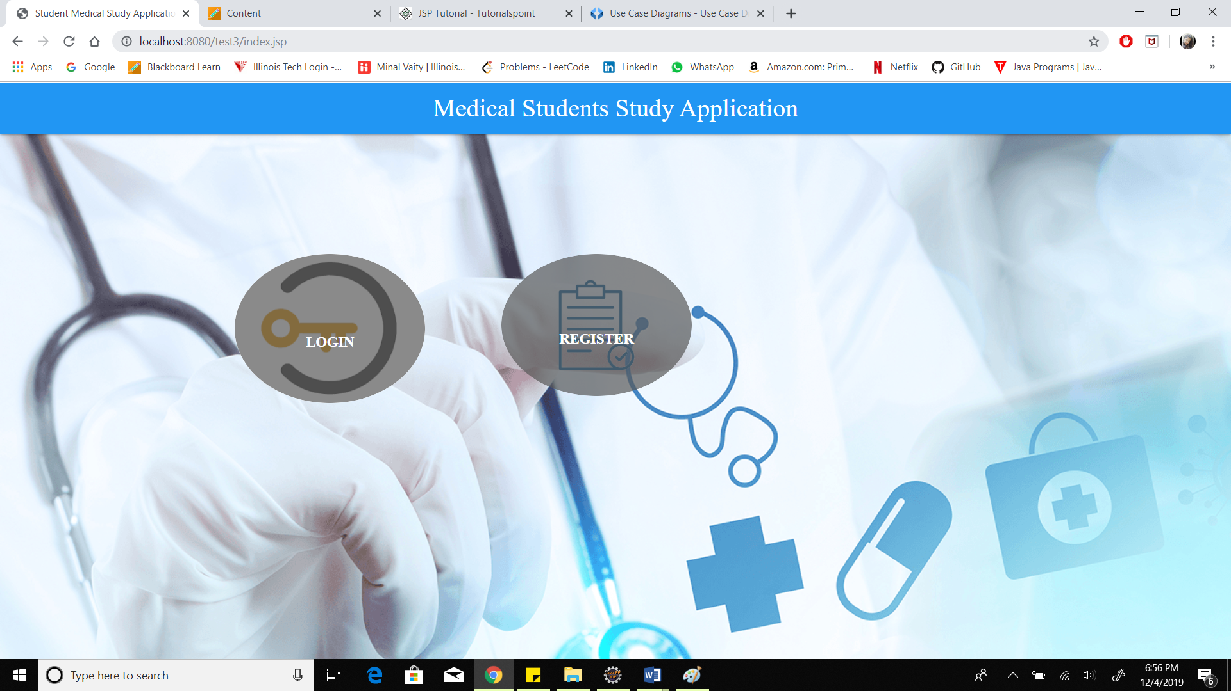

**Login Page**

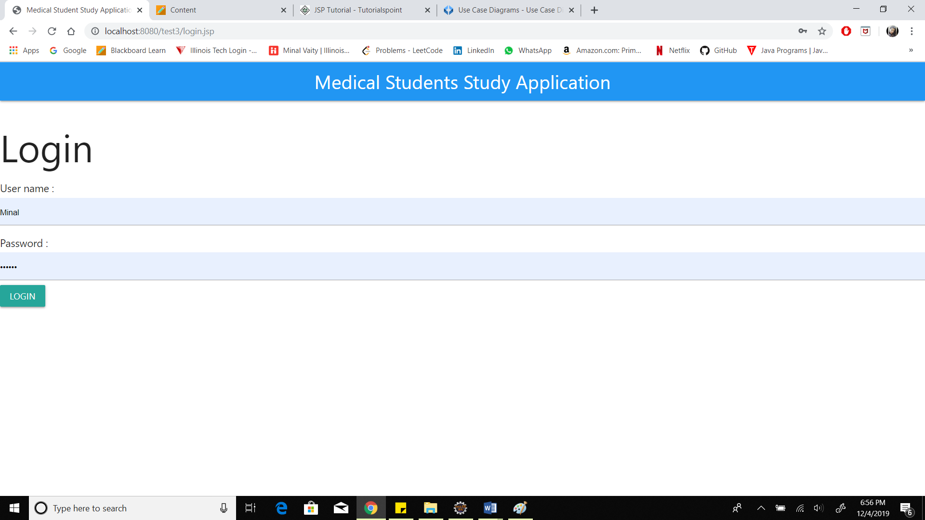

**Registration Page**

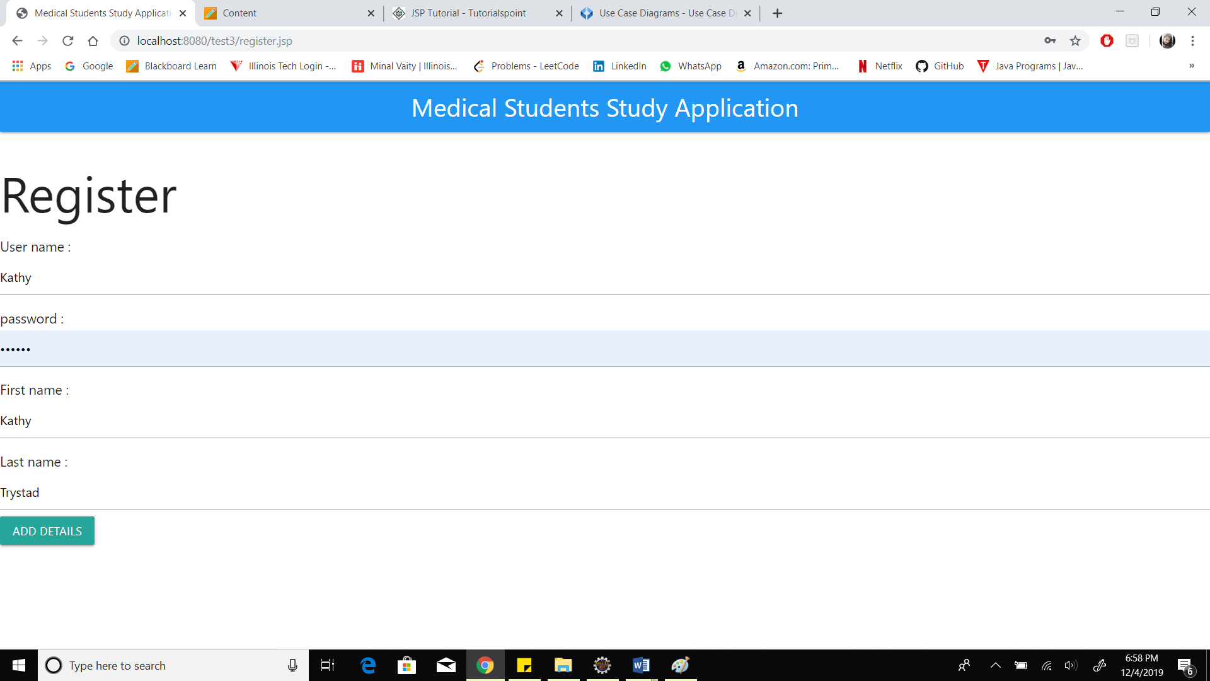

**Category Page**

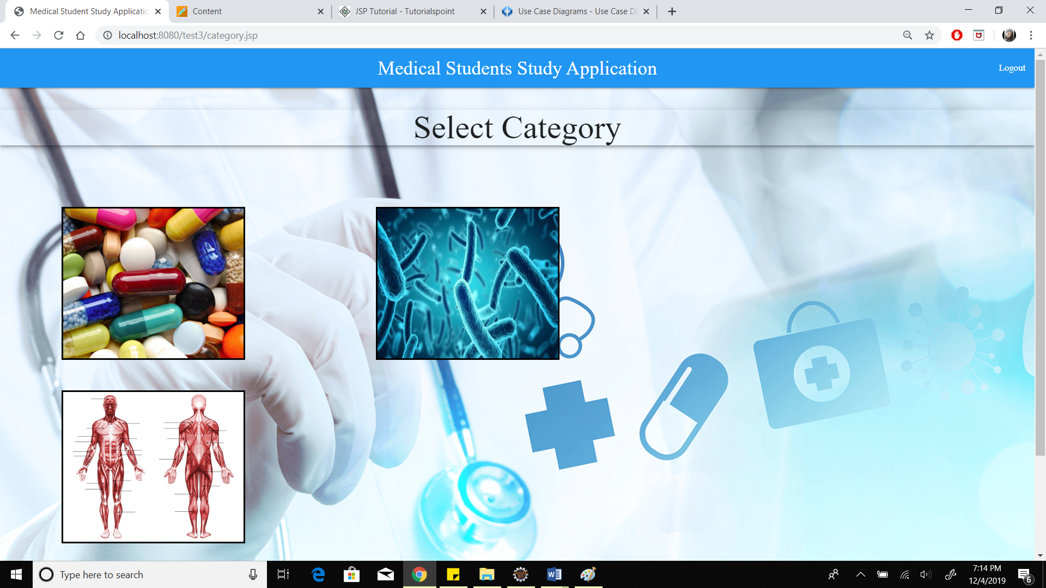

**On Clicking a Category on Page**

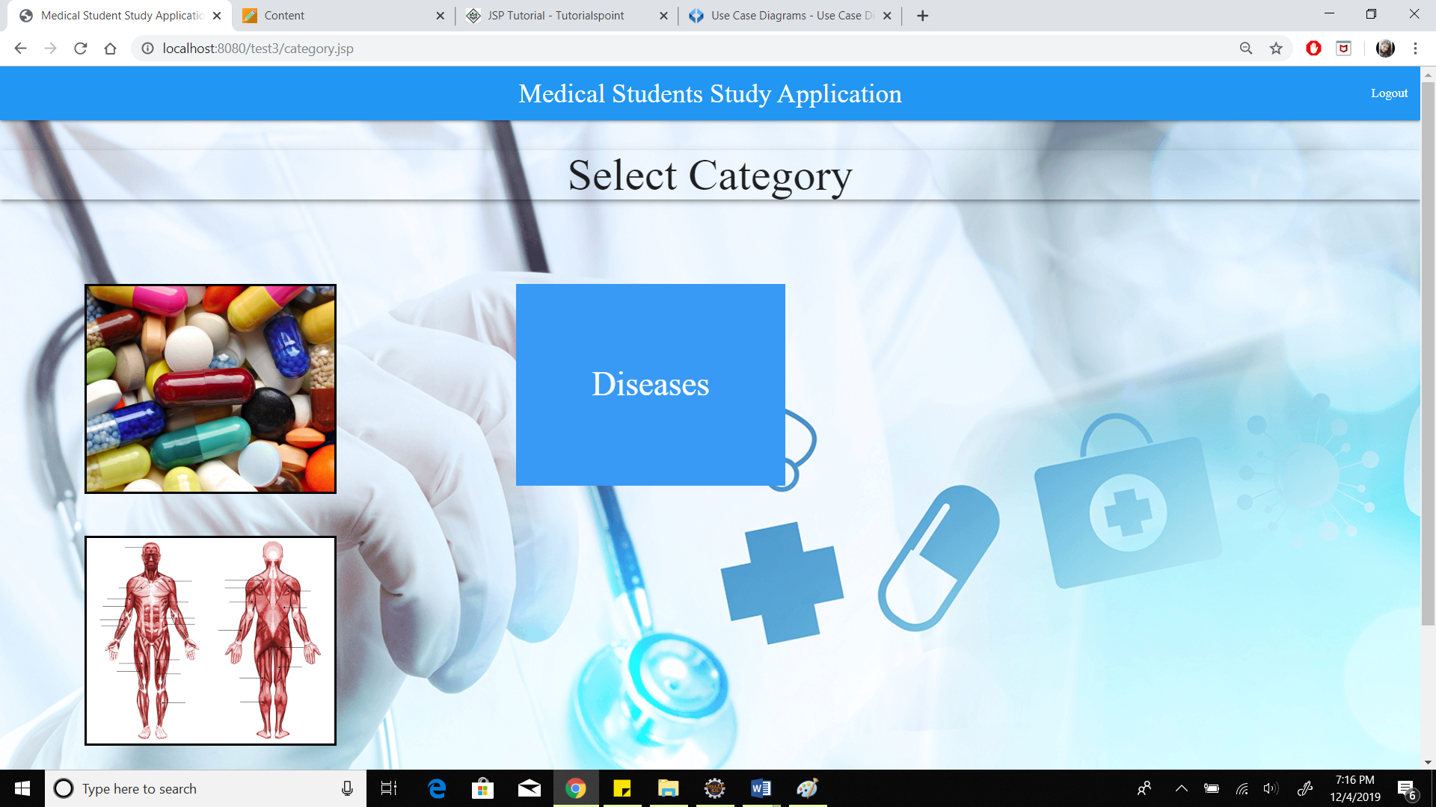

**Search Page**

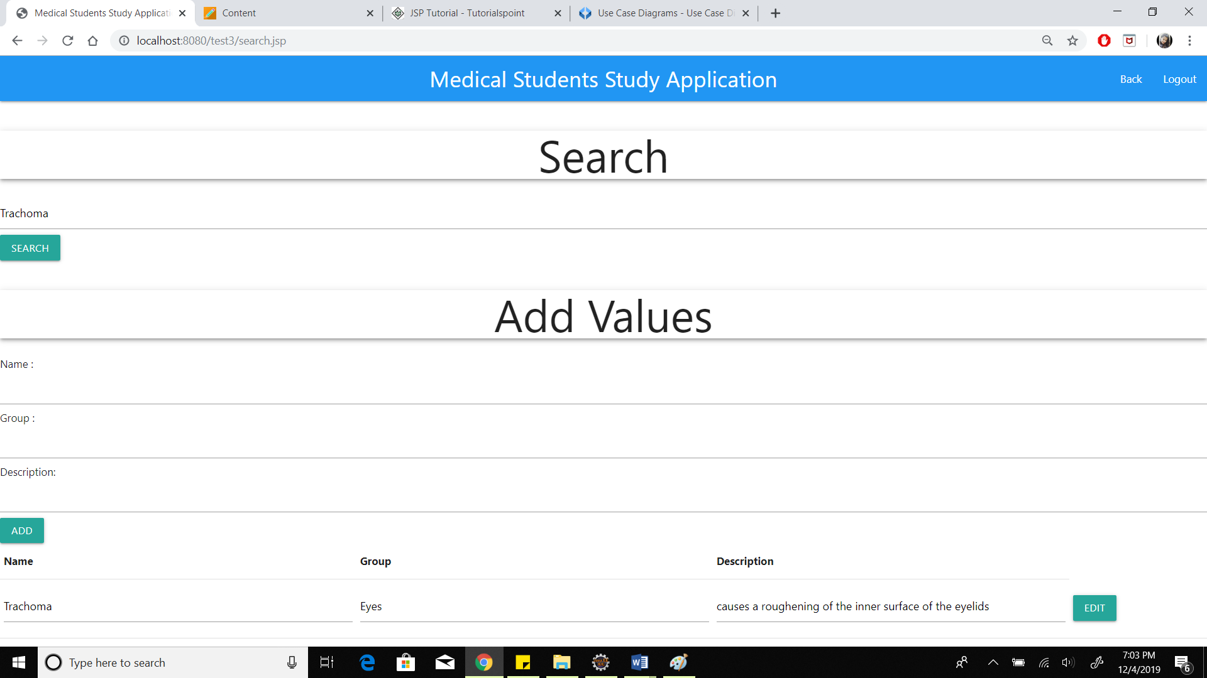

**Adding terms** 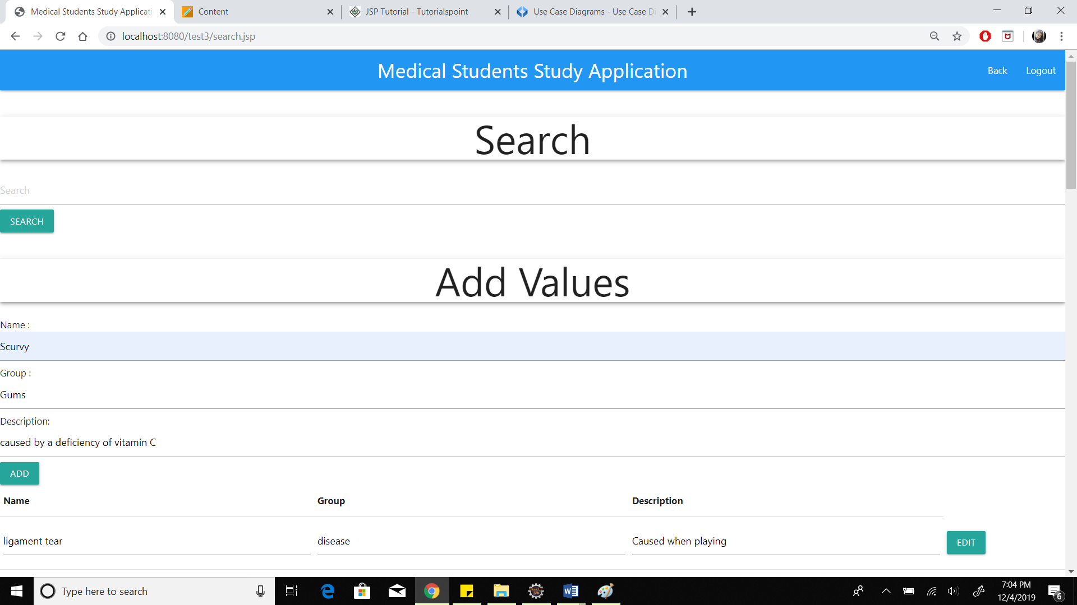

**Edit Page**

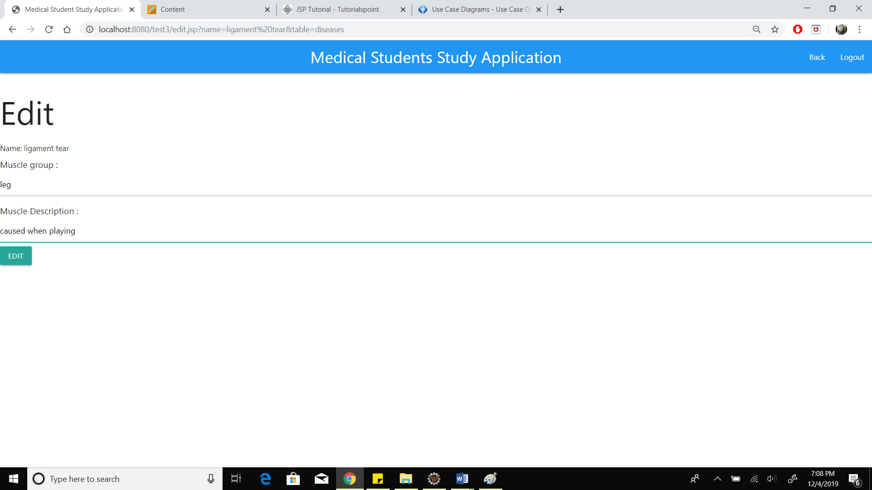

**Admin Category Page**

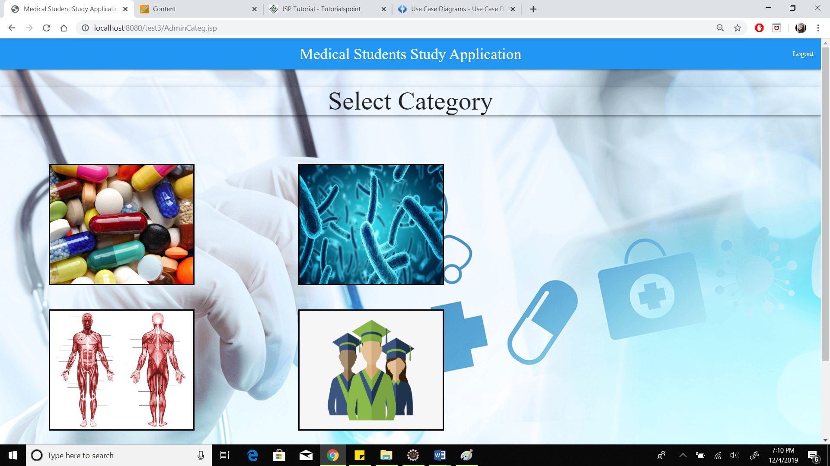

**Admin Search Page**

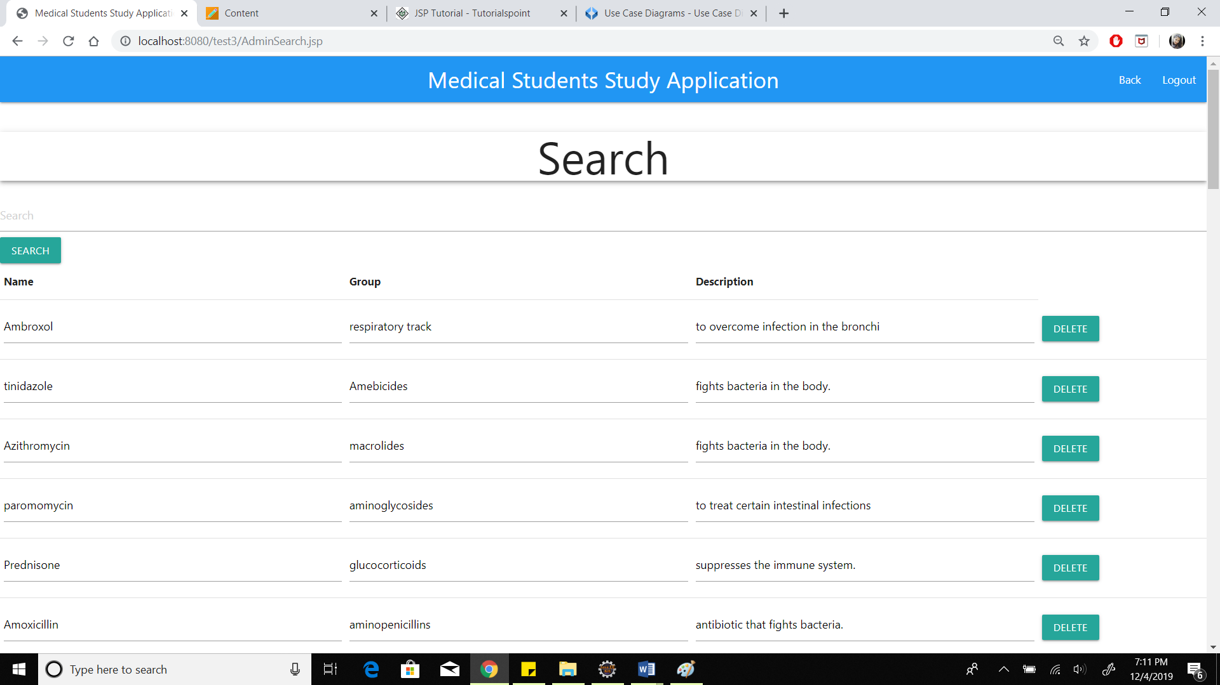

**Admin can access student data**

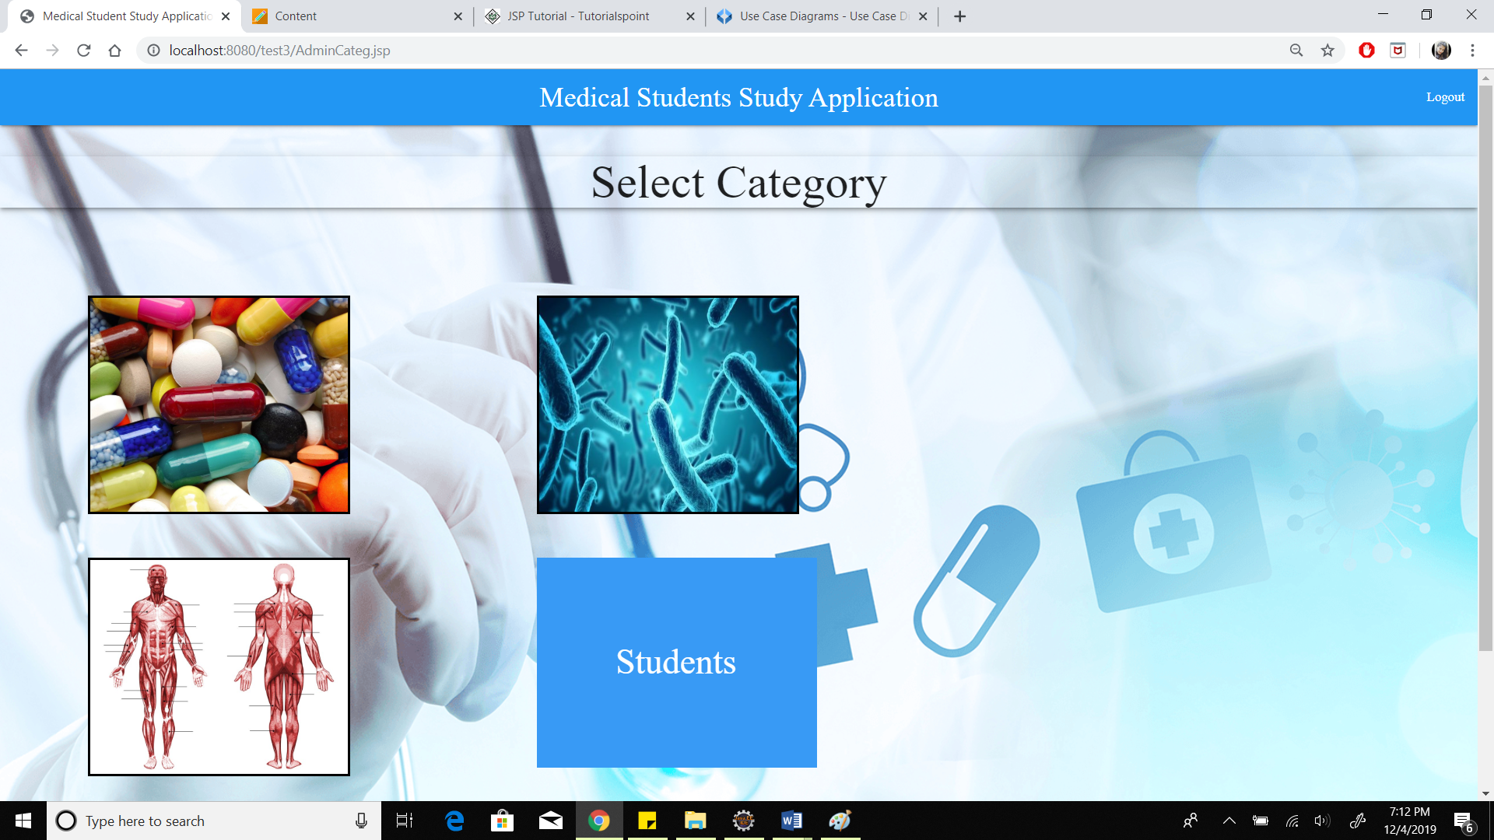

**Admin can search and delete student data**

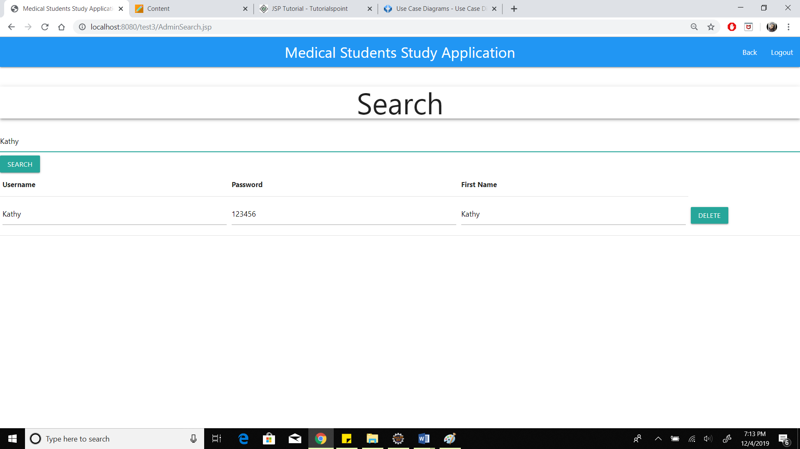

**Database Tables**

* users Table

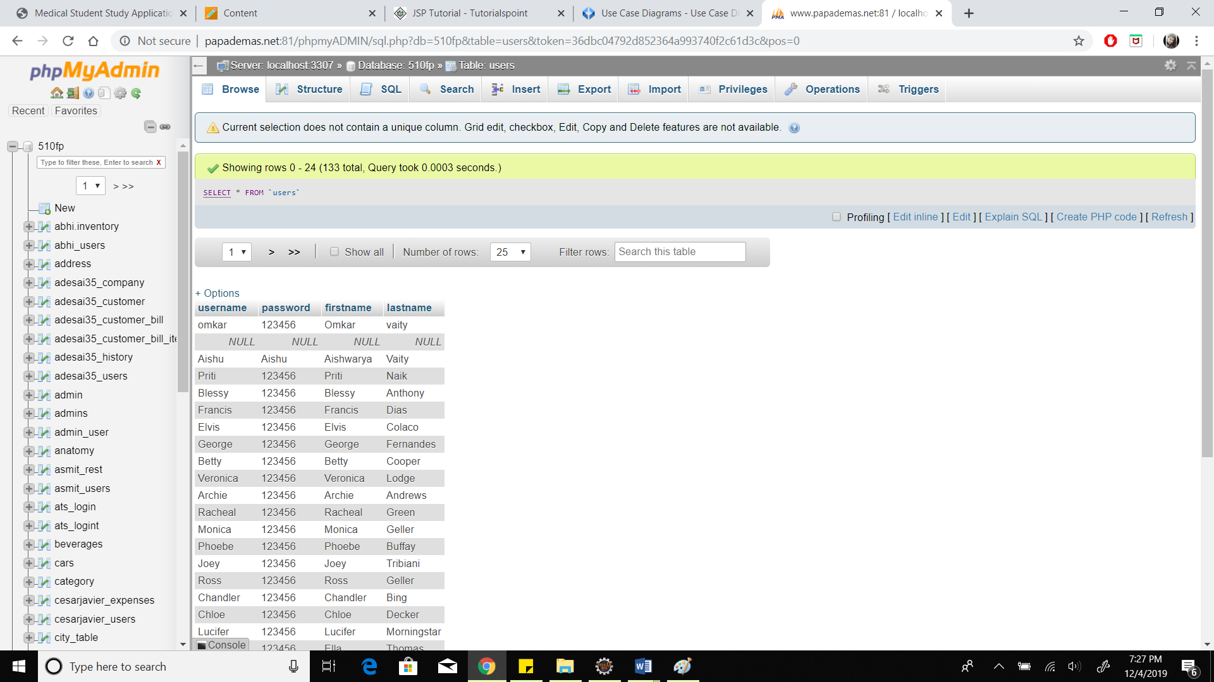

* anatomy Table

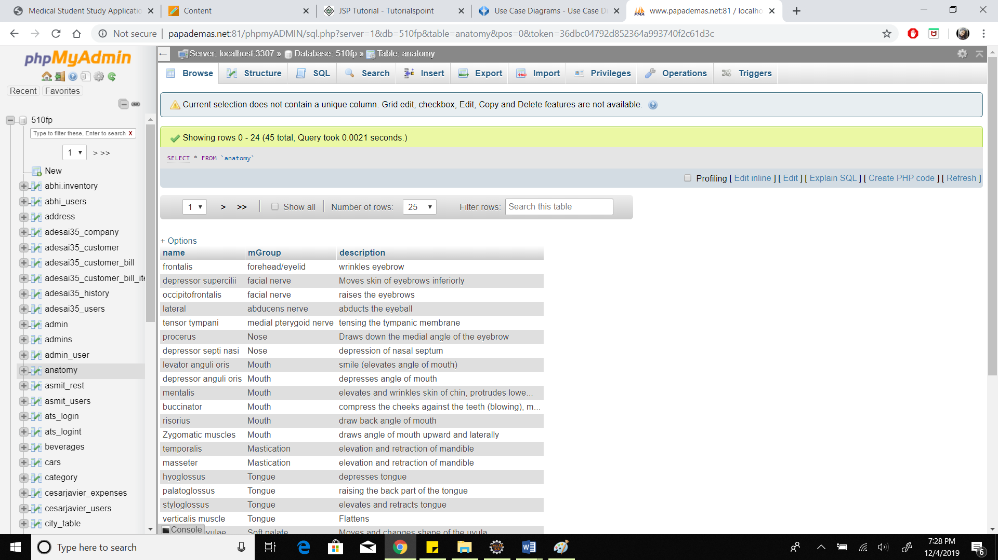

* drugs Table

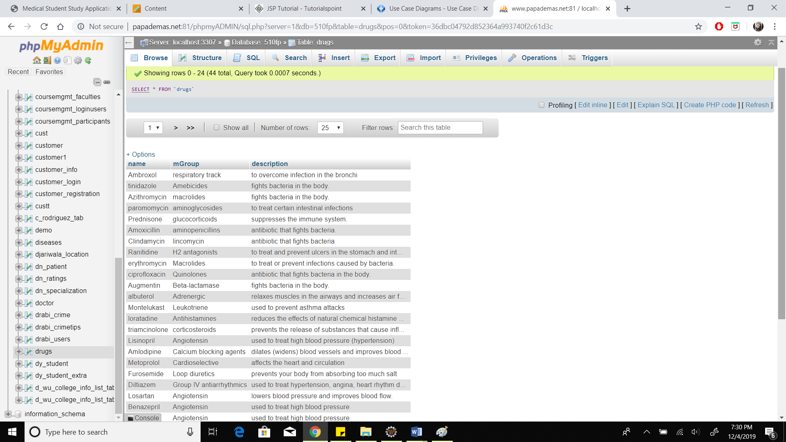

* diseases Table

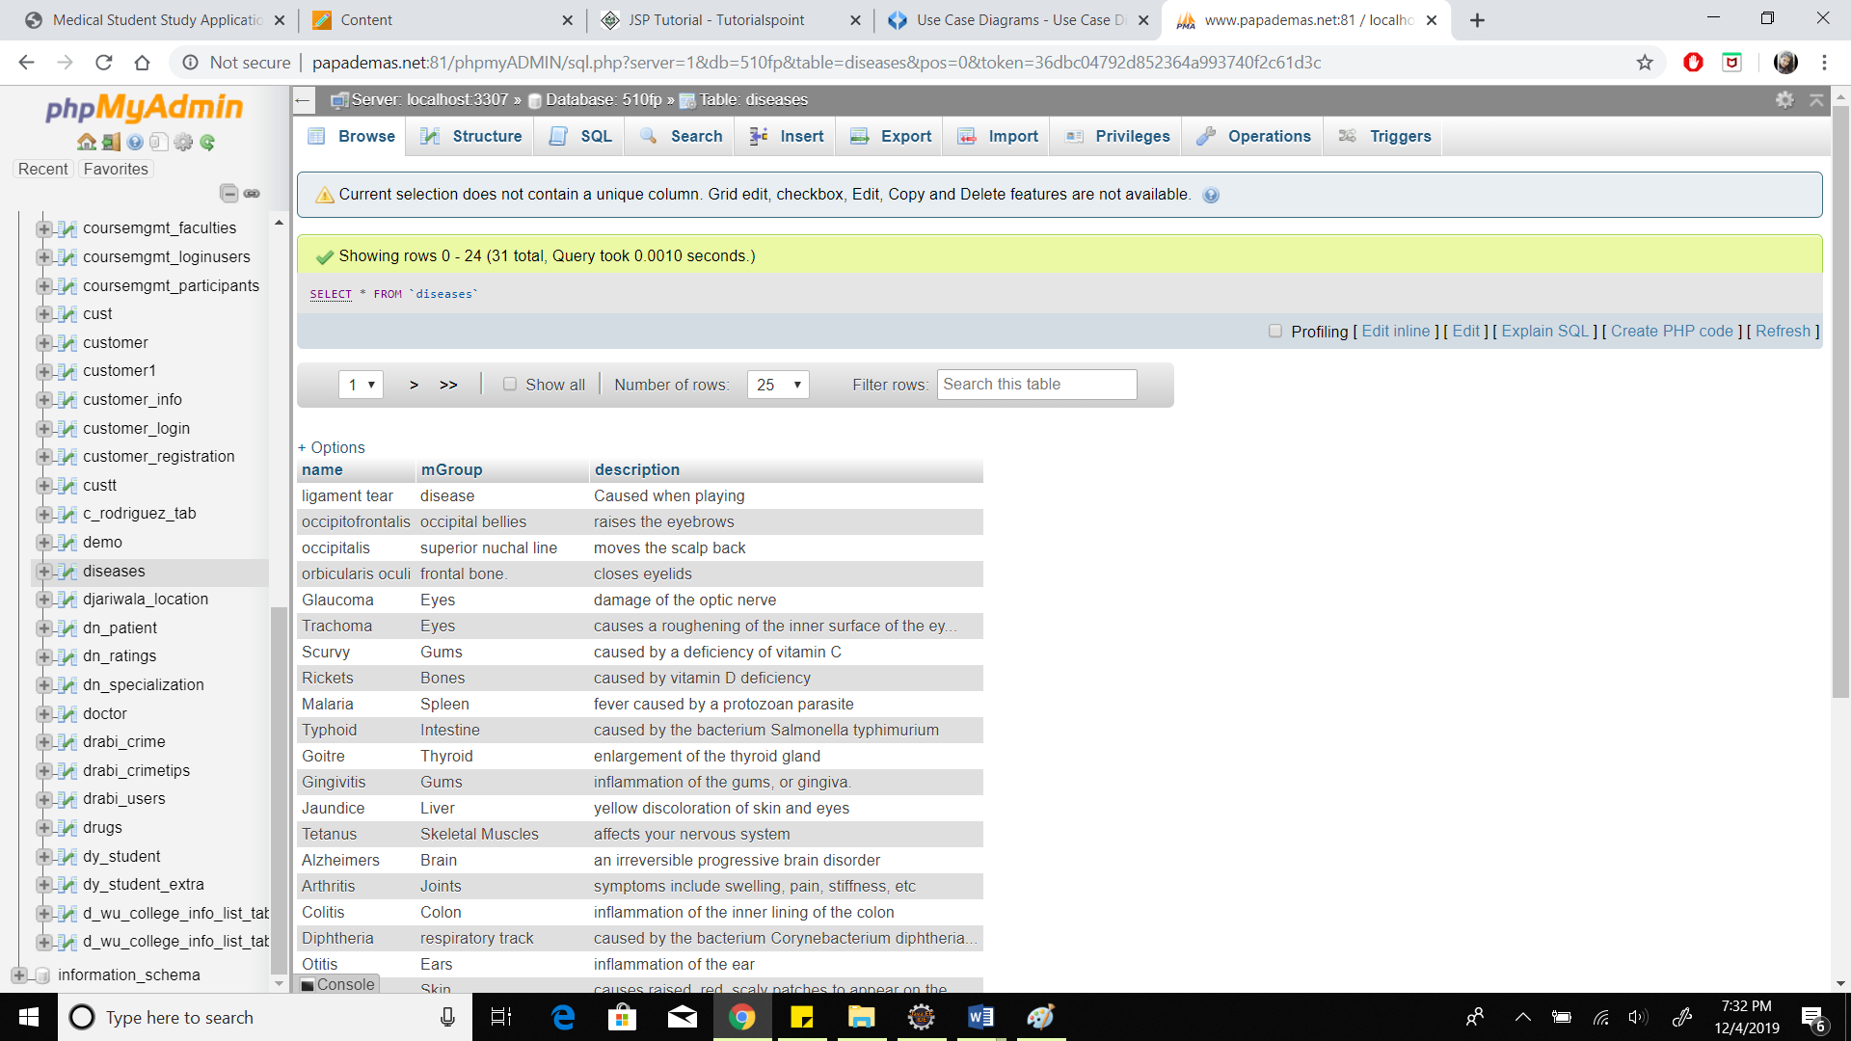

**Initial High-level Architecture : System Flow for both student and admin**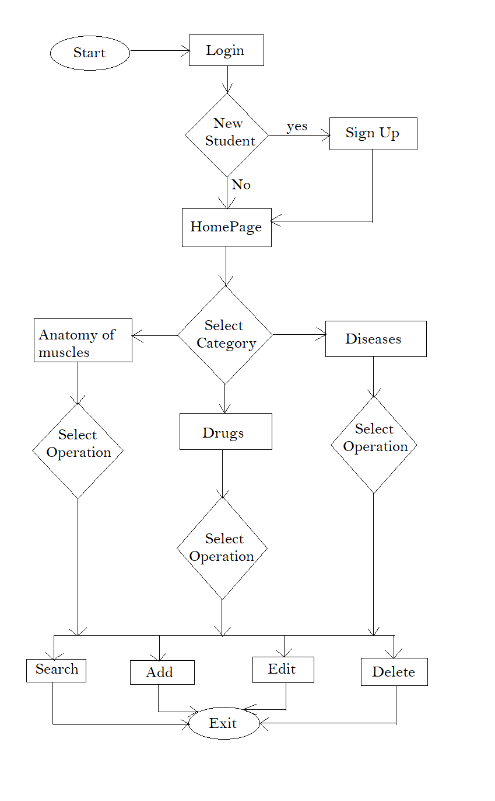

**ER Diagram**

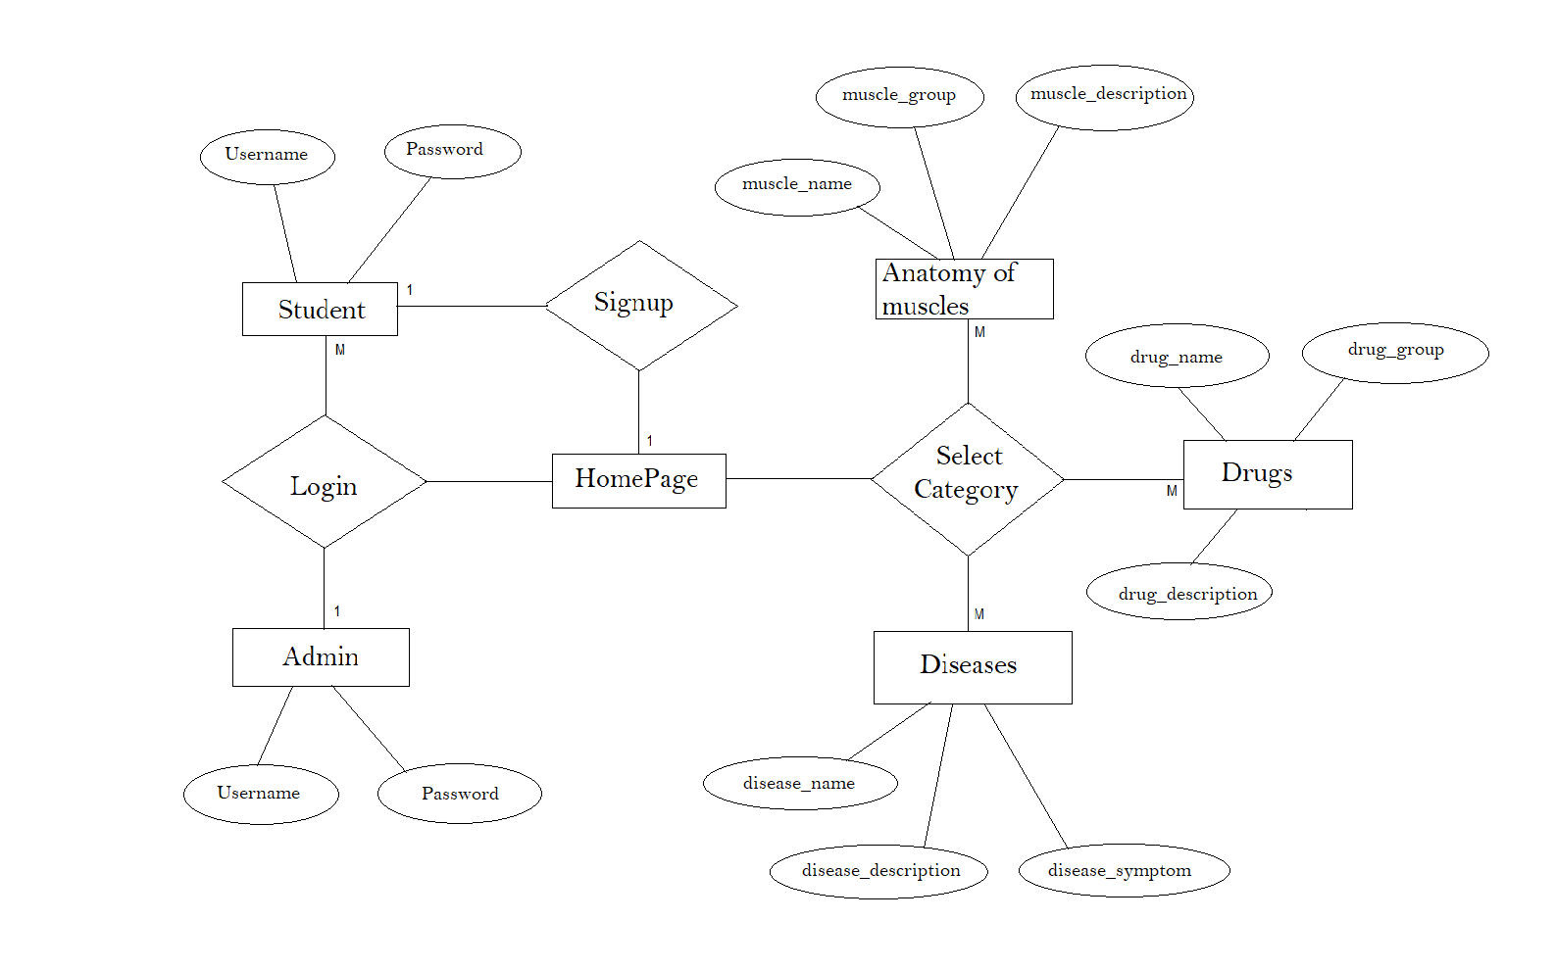

**Use-Case Diagram**

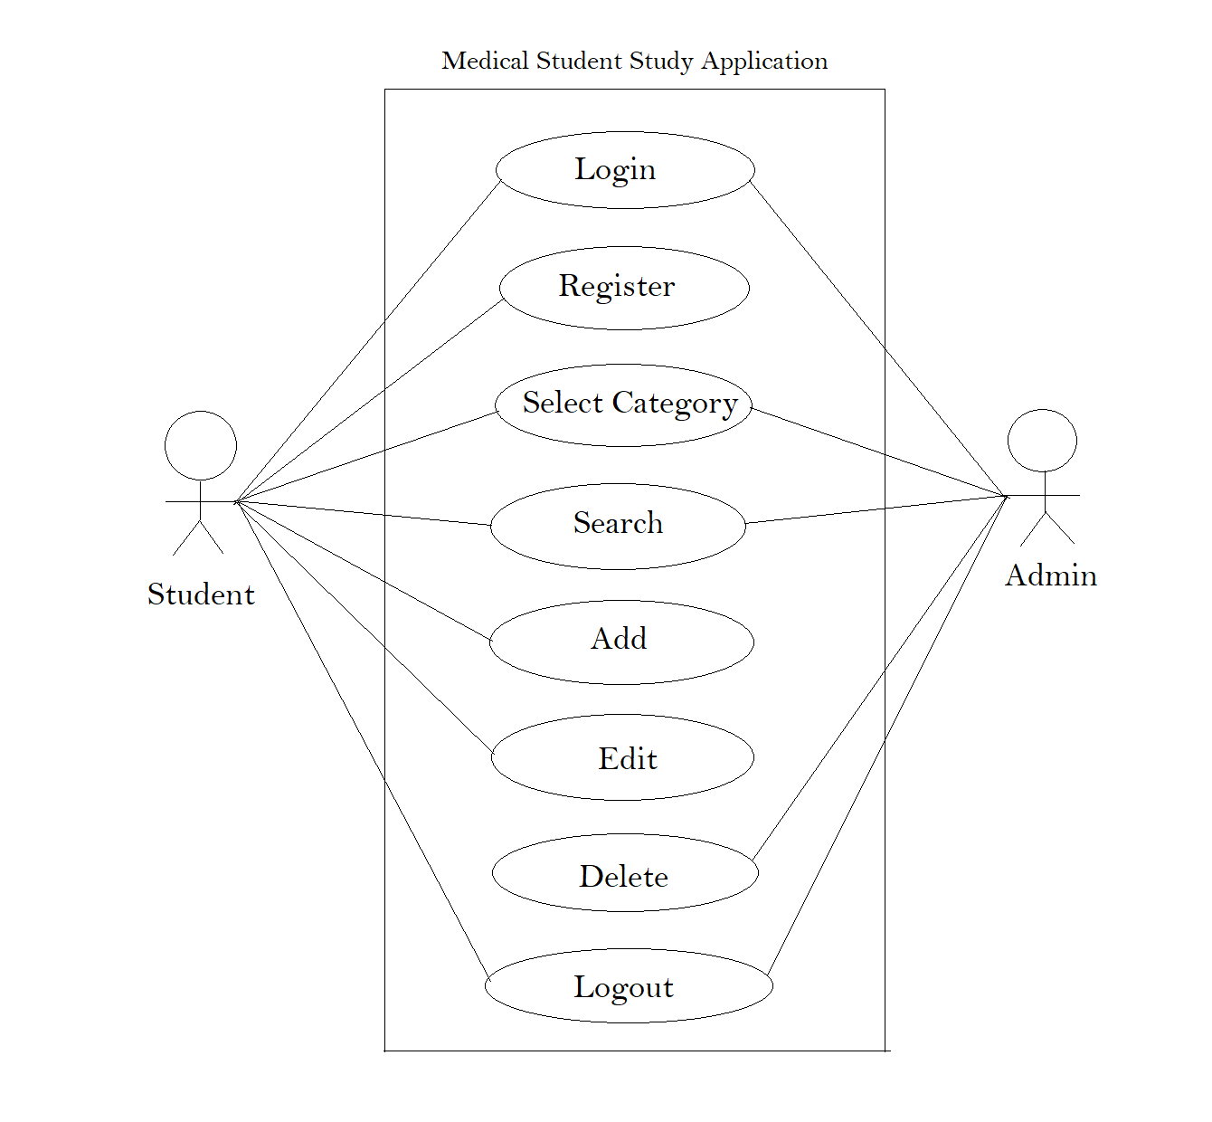

**UML Diagram**

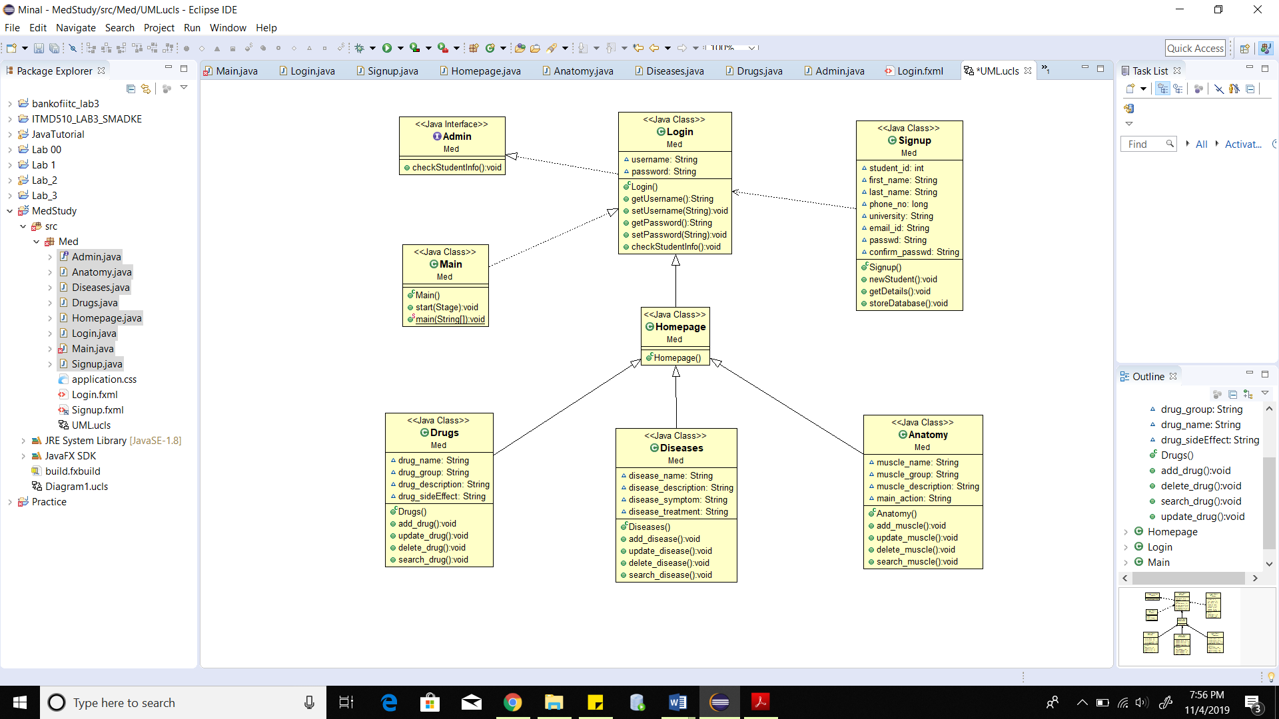

**Gantt Chart**

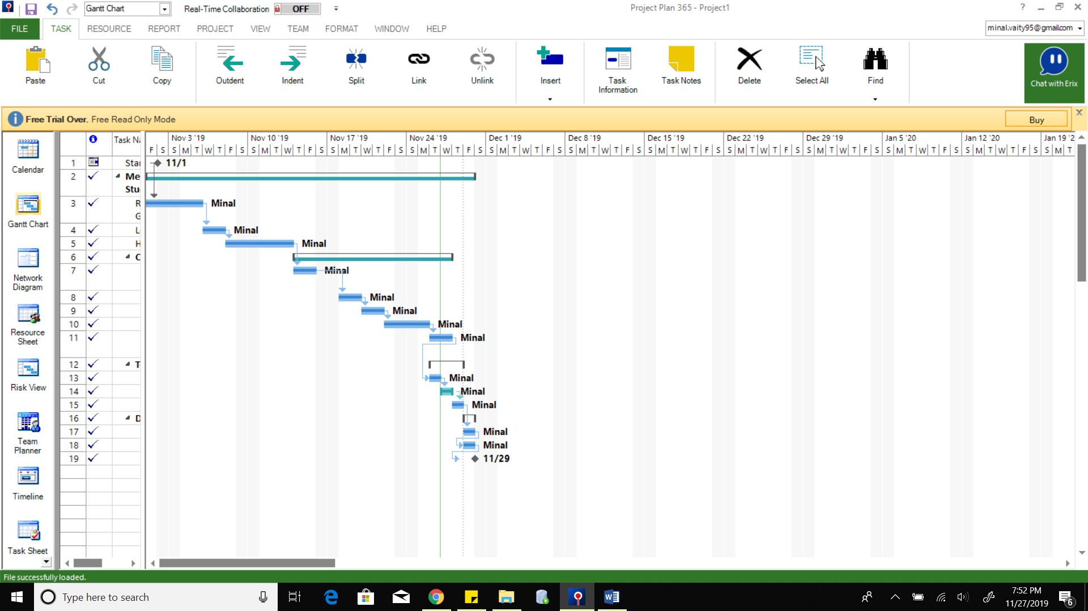

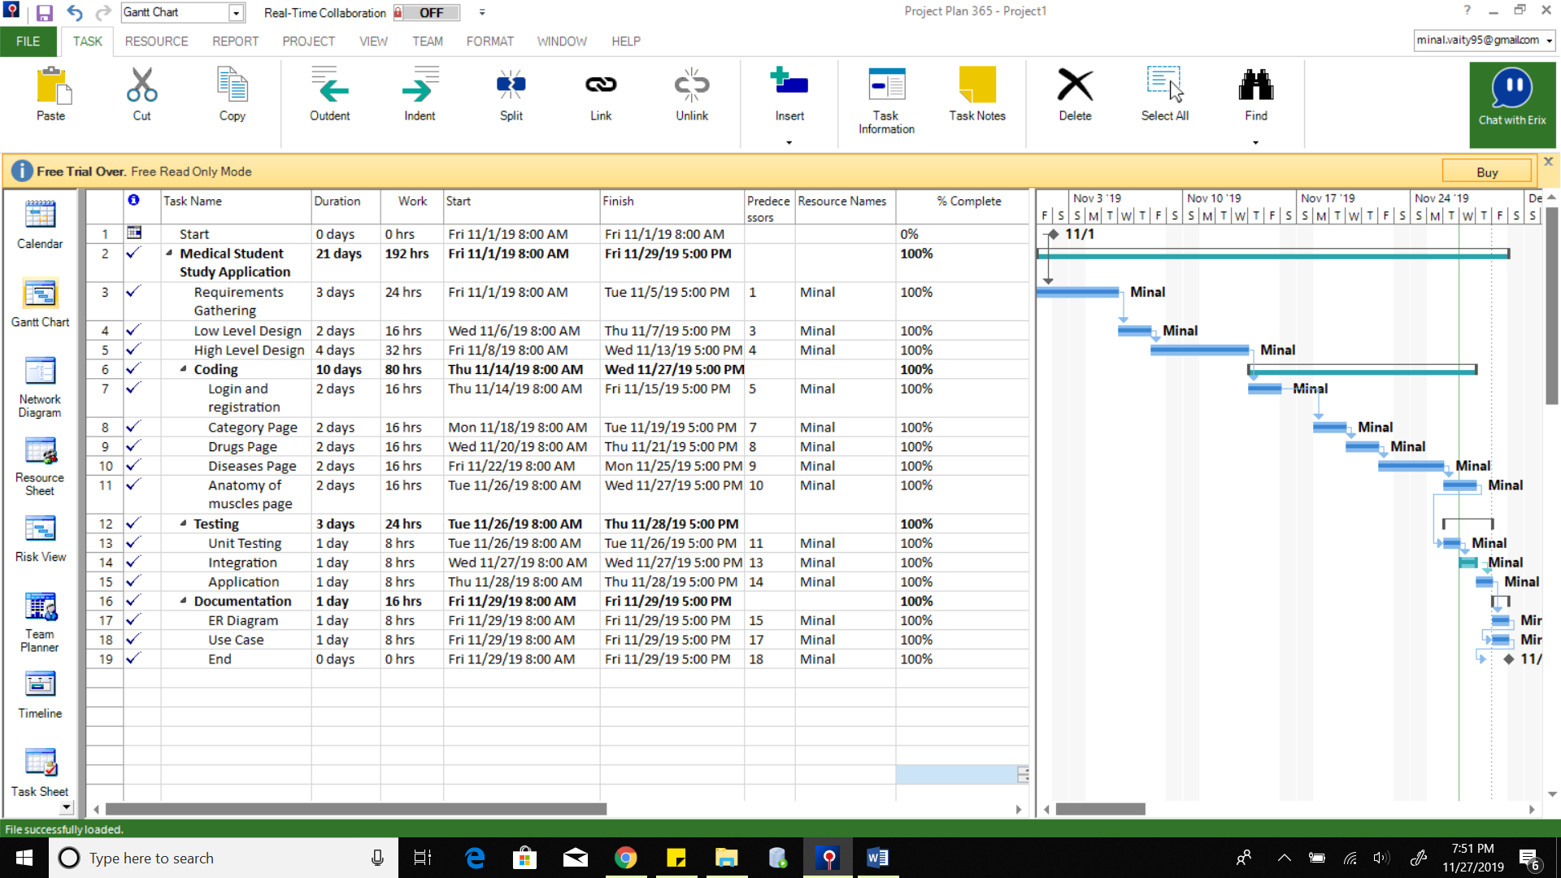

**Summary**

For medical students, learning how to diagnose and treat everyday illnesses, serious conditions and even life or death situations, is both complex and challenging. Fortunately, modern technology provides numerous medical apps for students and doctors. These help with everything from memorization and study planning, and give you access to countless resources, references, calculations, and much more. Therefore, in this project, by developing a medical study application, it is made easy for a student to study the different areas of their study like the anatomy of muscles, drugs, diseases, etc. in a very interesting way wherein the student can create their own study material while categorizing it in an efficient way to prepare for their exams.